# Notes from Exploring Programs

## Instructions

Make a copy of this document, rename it to “exploring-programs-notes” and move it to your CSE 523 Google Docs collection. If at any point in this exercise you feel stuck, raise your hand and get some guidance. When you reach each GATE below, switch over to the Tracking Progress document and update your position. Try to be efficient with your time.

## Overview

Today we will explore program binaries and running processes. Keep detailed notes below (place your comments in between the provided horizontal lines); you will be referring to these in the future to do your work.

## Part 1: Linux

For this part, you will be working in your Ubuntu VM, so start that now.

### 1.1 Static Binaries

In this exercise, we will be working with the Linux utility **date**. Enter the following command lines in a terminal window.

date

date --date=”4 hours ago”

date --date=”2 years ago” +%Y%m%d

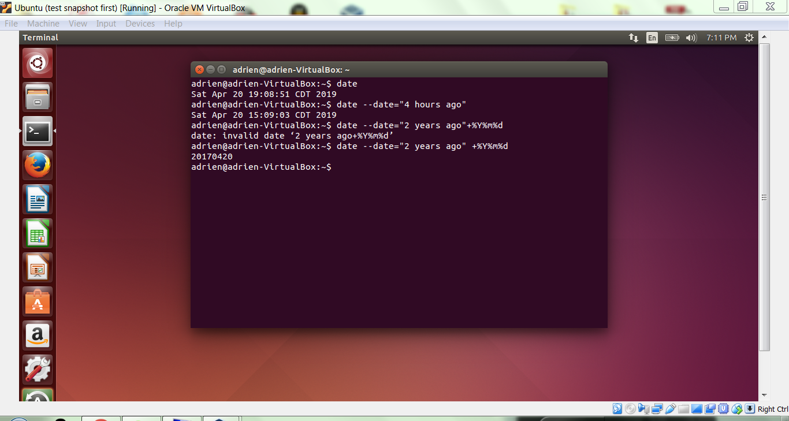

Where is the program **date** in the filesystem? Show how you found it below (ie, show the command line and its output.)

Date:

/bin/date

/usr/share/man/man1/date

Briefly describe what the program **objdump** does.

objdump is a command-line program for displaying various information about object files on Unix-like operating systems. For instance, it can be used as a disassembler to view an executable in assembly form. It is part of the GNU Binutils for fine-grained control over executables and other binary data.

Enter the following command at the terminal, replacing {loc} with the location you found above (you probably want to find-replace {loc} for your location so that you can copy and paste directly). This will pipe the output of objdump -d into a program called less. Here are some quick and easy commands to learn to make less easier to navigate. Note that, much like Vi(m), less interprets your keypresses as commands at the output window.

Scroll up (J), scroll down (K), start a forwards search for a string (/), start a backwards search for a string (?), quit less (q), scroll down one window (SPACE), scroll forwards ½ window (d), and scroll back ½ window (b). Now you know enough to be quick using less!

Explain what you see below, using only a few sentences.

objdump -d {loc}/date | less

The output of the above command produce a lengthy informative text about the date. Information includes file format, disassembly of section .init, disassembly of section .plt, etc.

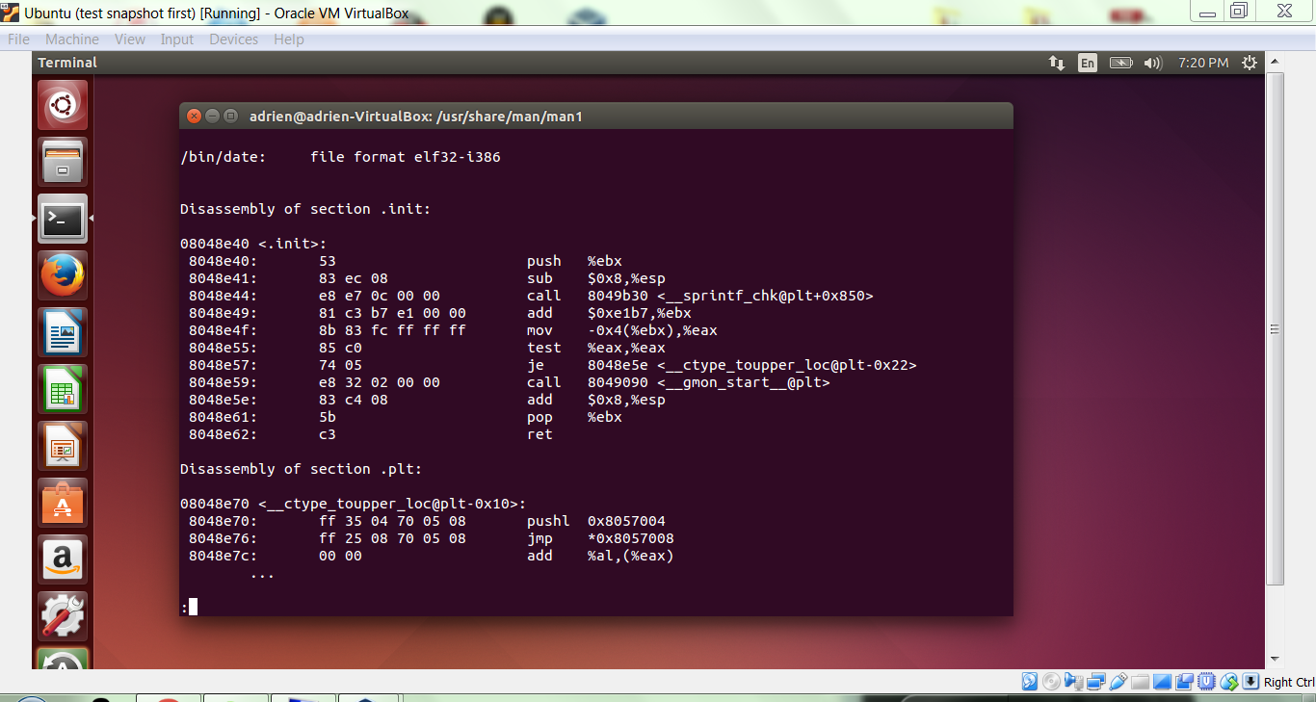

# GATE 1

Enter the following command at the terminal, contrast this output with the previous output, and explain what the -xtrds switches mean.

objdump -xtrds {loc}/date | less

-xtrds displays an overview of the date and the sections inside. Information includes file format, architecture and program headers.

-d is disassembly of the sections.

Therefore –d contains much more information while both produce pages long output

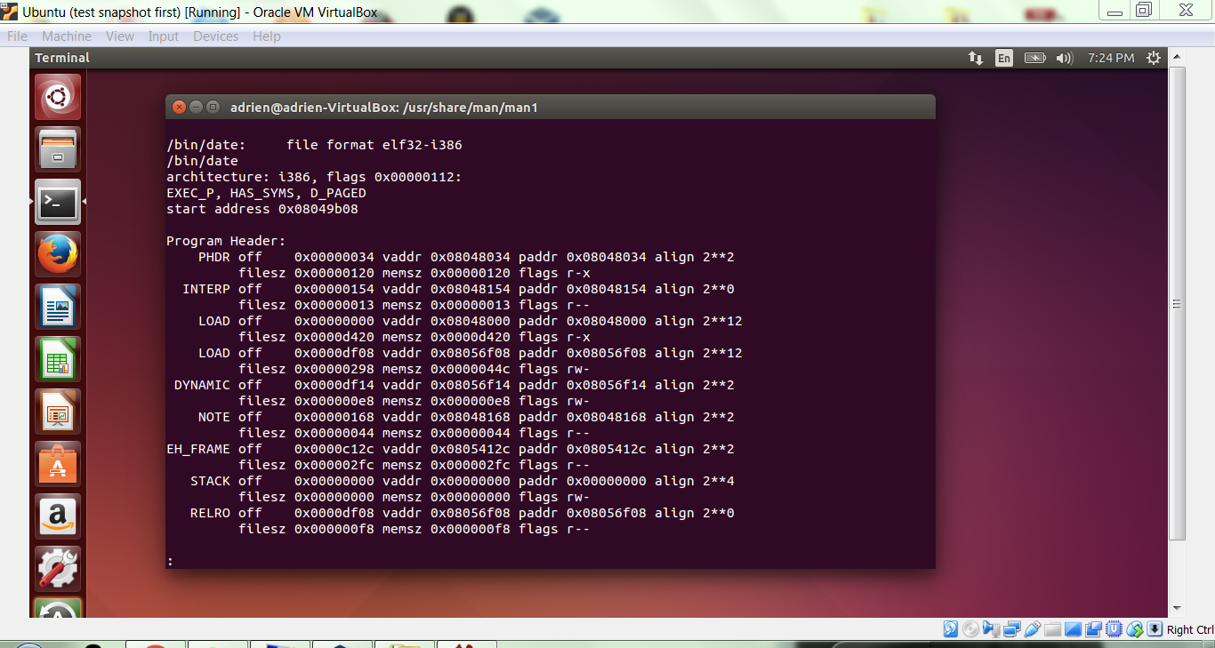

Enter the following command at the terminal, and note the output below.

objdump -xtrds {loc}/date | grep bugs

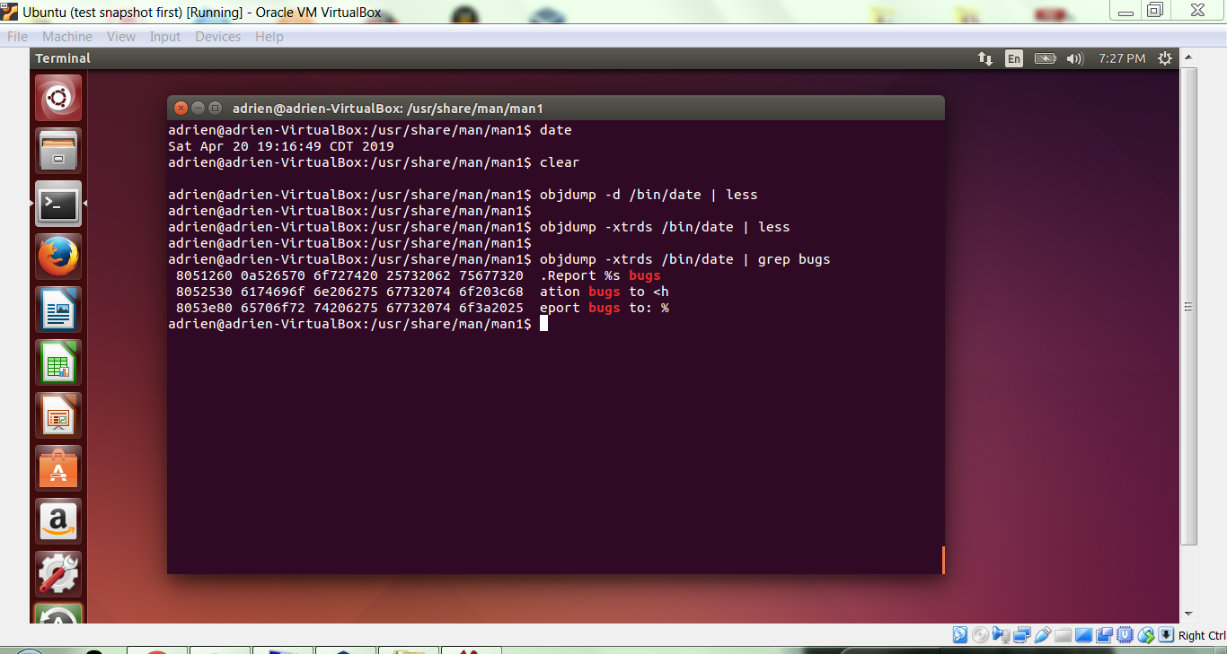

**GATE 2**

Make a copy of **date** in your home directory. Launch **ghex** . Briefly describe the tool and its purpose below.

GHex is a simple binary editor. It lets users view and edit a binary file in both hex and ascii with a multiple level undo/redo mechanism. Features include find and replace functions, conversion between binary, octal, decimal and hexadecimal values, and use of an alternative, user-configurable MDI concept that lets users edit multiple documents with multiple views of each.

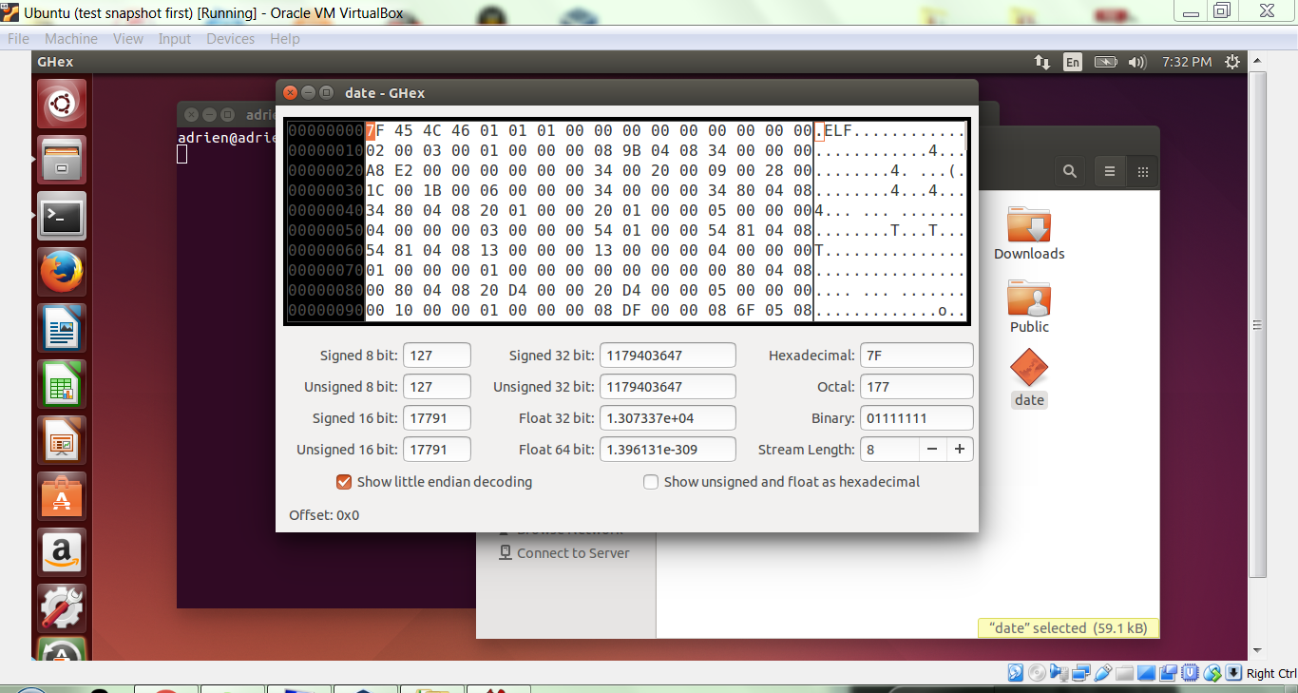

Open your local copy of date in **ghex**. Look familiar? Go to Edit > Find, type in “bugs” into the right pane and click “Find Next”. In the right-hand column, you should see the string “bugs” on the last line. At the cursor’s present location on the left side, change the hex numbers “62 75” to read “64 6F”. Save and quit with File > Save and File > Exit. Go back to the terminal and run (the local version of) “./date --help”. Explain the differences below.

In the last line the word “bugs” became “dogs” because we change the ascii value for the displaying characters.

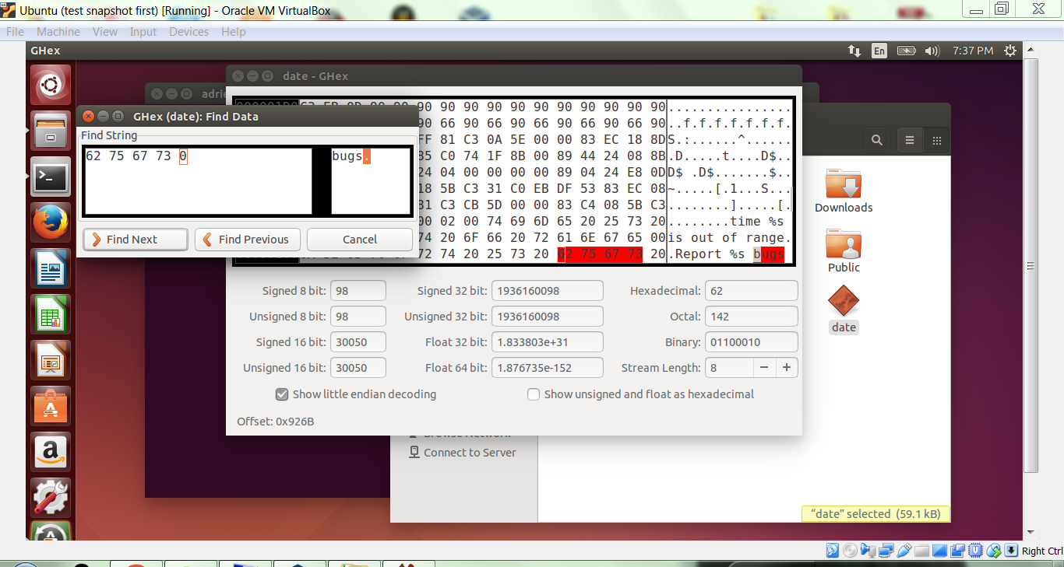

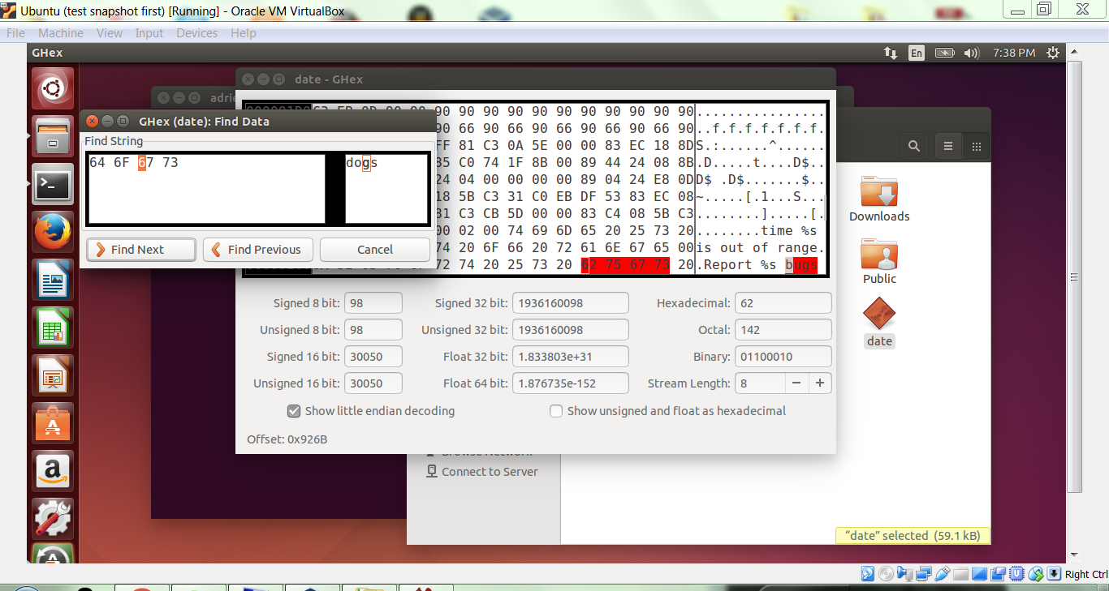

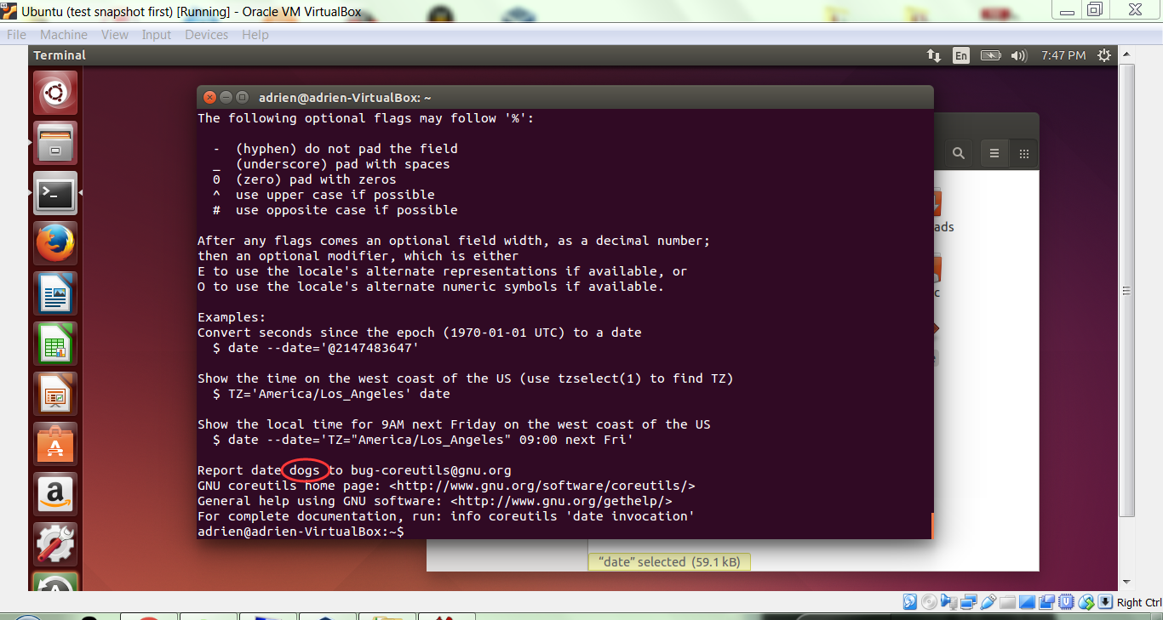

Use ghex to make another, more interesting change to your local copy of date, and explain it below.

Searched for the word “America” and changed the integer value on the left hand side to “61 63 69 72 65 6D 41” and saved the file. The word “America” became “aciremA”.

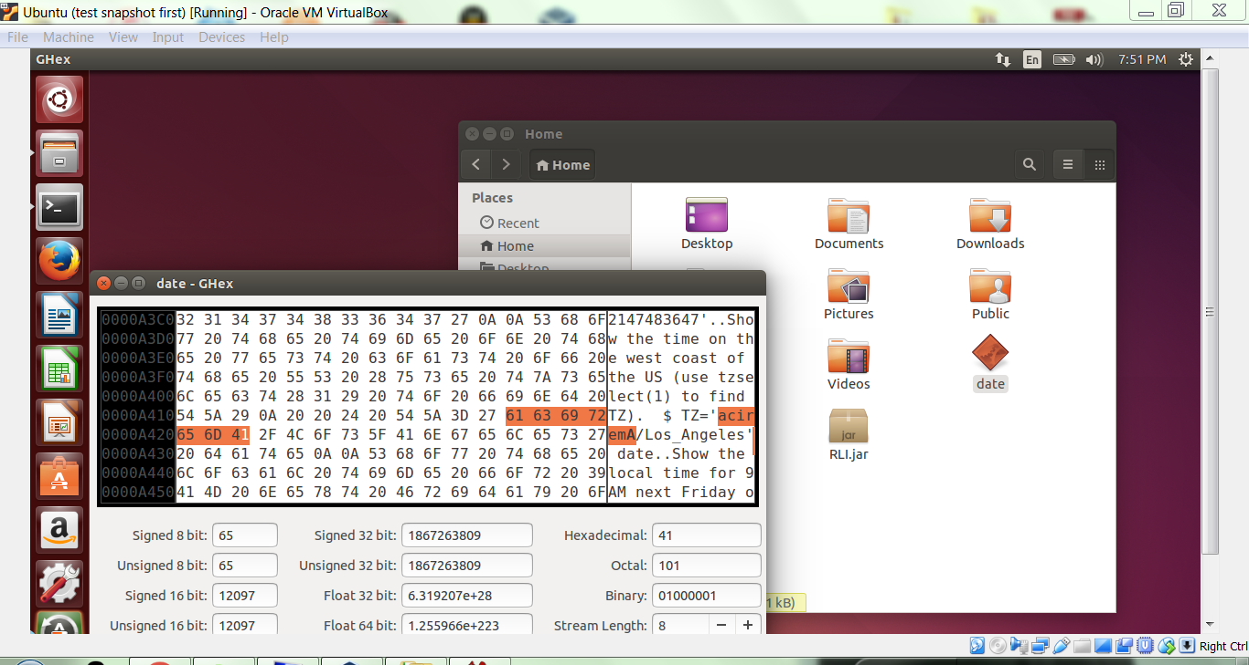

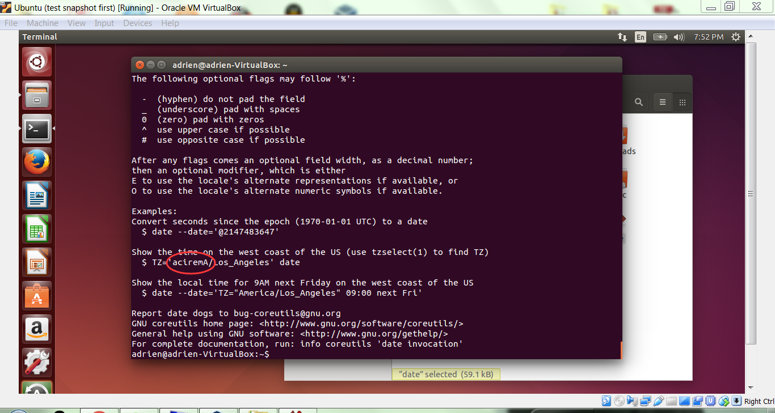

**GATE 3**

Another useful tool is available: readelf. ELF is the object file format used in Linux and many other systems. Execute the following commands at the terminal, and explain what each one shows you. If you’d like, you can keep a copy of each output in this file for future reference.

readelf -l {loc}/date

readelf -S {loc}/date

readelf -W -s {loc}/date

readelf -x 16 {loc}/date

readelf -l {loc}/date Display the program heads and segment mapping

readelf -S {loc}/date Display section headers and key to flags

readelf -W -s {loc}/date Display the entries of the symbol table ‘.dynsm’

readelf -x 16 {loc}/date Display the hex dump of section ‘.eh_frame_hdr’

**GATE 4**

### 1.2 Using gdb

At the terminal, enter the following

gdb

(gdb) help

Use the interactive help feature to explore gdb’s options.

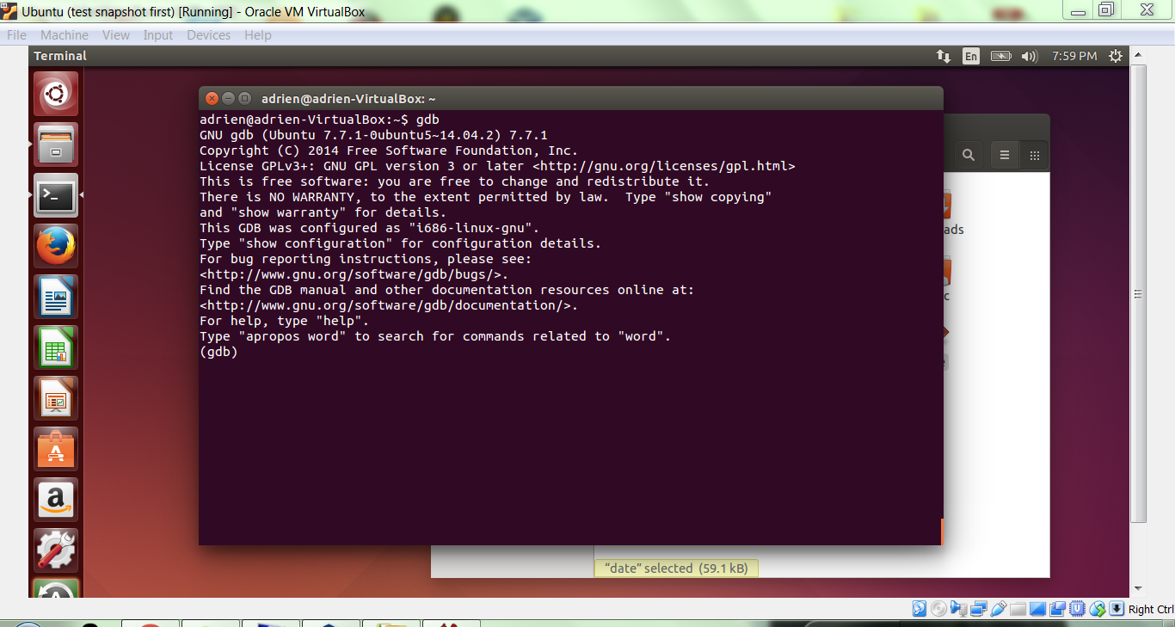

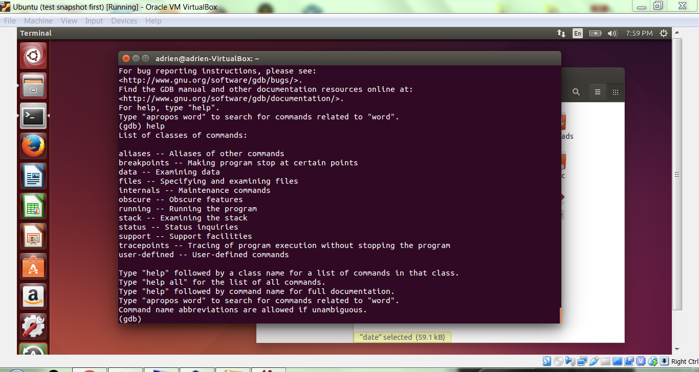

### GATE 5

### 1.3 Examining processes

At the terminal, enter the following.

gdb date

(gdb) run

(gdb) quit

Copy your output below.

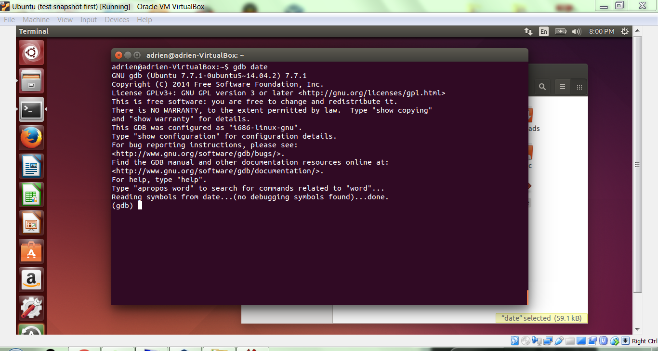

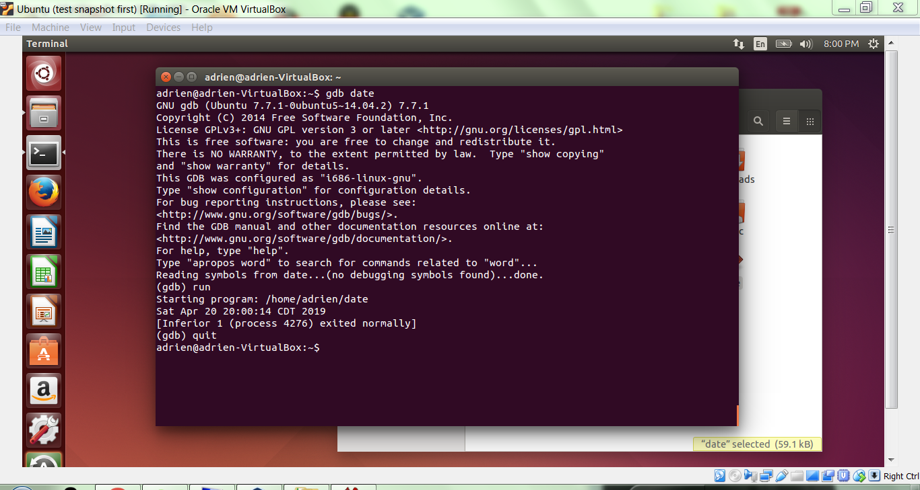

Try the following commands to get a feel for the tool.

gdb date

(gdb) set args “--help”

(gdb) break __libc_start_main

(gdb) run

(gdb) frame

(gdb) bt

(gdb) info frame

(gdb) info registers

(gdb) x /16xw $rsp

Explore other registers and memory locations. What can you say about where the code and stack are located?

The stack pointer RSP points to the last item pushed onto the stack, which grows toward lower addresses. The stack is used to store return addresses for subroutines. The instruction pointer, is a special register in a processor. It holds the address of the next instruction to be executed.

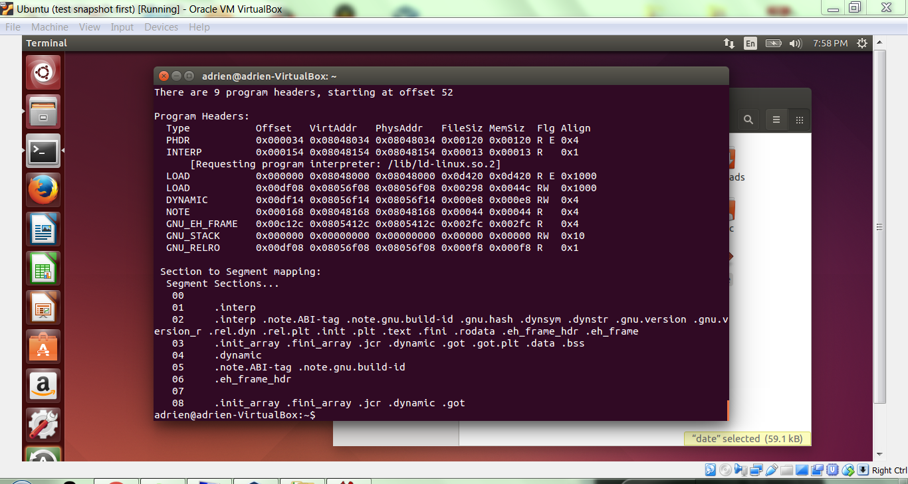

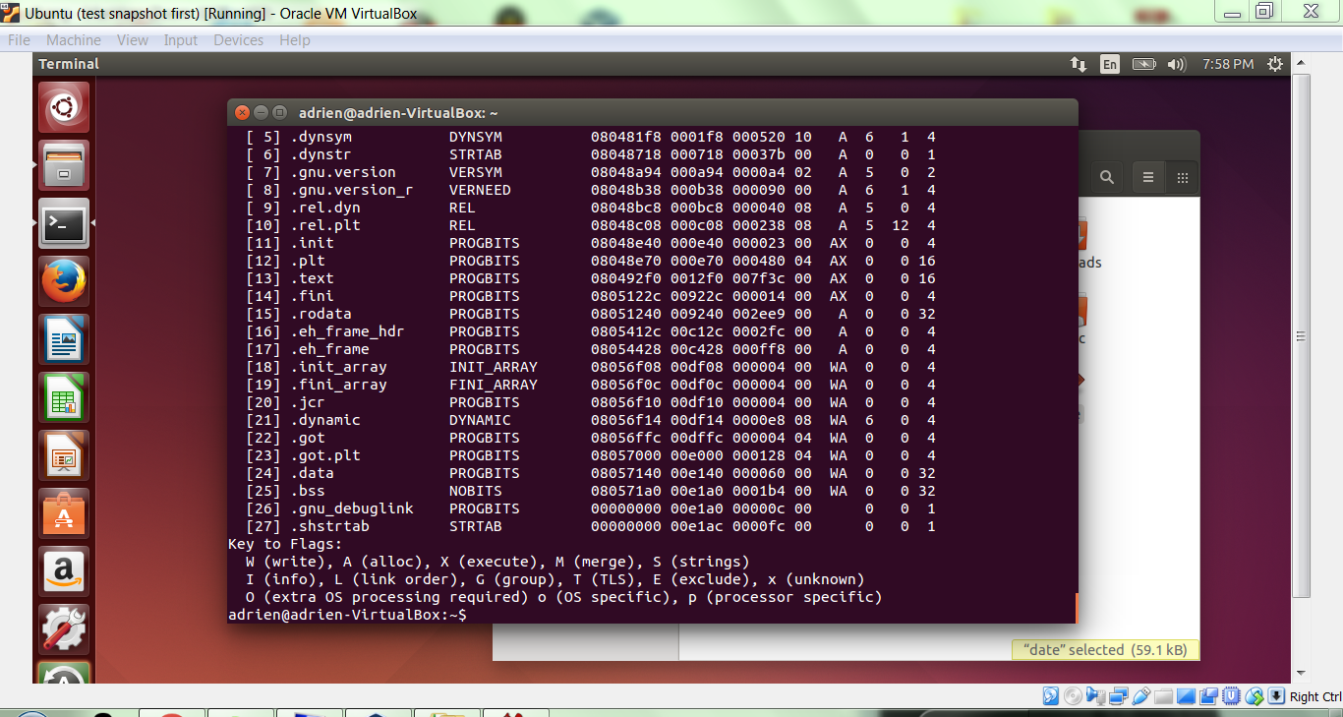

**GATE 6**

Now try the following.

gdb date

(gdb) set args “--version”

(gdb) break __libc_start_main

(gdb) run

(gdb) maintenance info sections

note the start address of the .rodata section

(gdb) x/20s {.rodata address}

note the start address of the string “GNU coreutils”, {start}

(gdb) set *{start} = 0x20554c42

(gdb) c

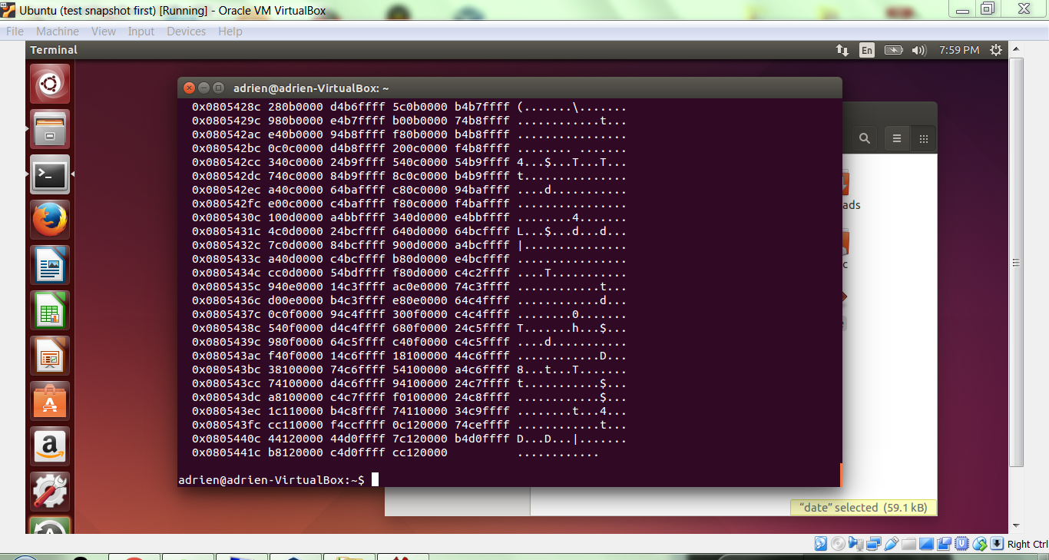

What is the code above doing? Can you modify it to do something else that demonstrates that you understand? Did you run into a snag? Provide your explanation and your modification below. A reference like this might be helpful: <http://www.asciitable.com>

The word “GNU” is changed to “BLU”

**COMPLETE**